How to Access TM1 Remotely

Note: This document explains how to access TM1 within a provisioned Instance using your local computer.
After confirming TM1 works within the provisioned instance itself, you now must alter your local machine’s Windows HOSTS file which is located at: C:\Windows\System32\drivers\etc\hosts
Step 1: Open the HOSTS file with Notepad and add an entry that maps your provisioned instance’s IP address to ibmdemo.demos.ibm.com and ibmdemo. An example screenshot is below:
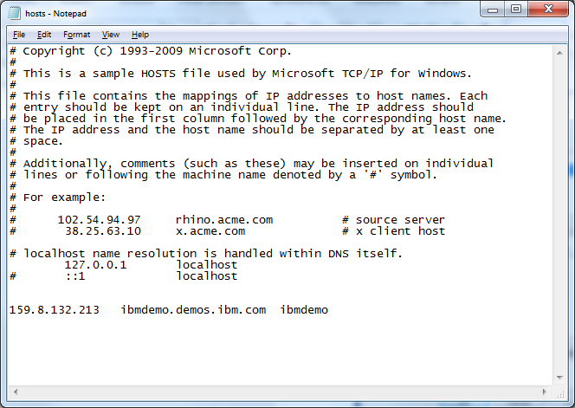

Step 2: Save the HOSTS file. If your HOSTS file will not save due to Security settings on your laptop, try the following troubleshooting steps or contact your IT Department:
To alter the HOSTS file, you will need to be certain:
- It is not Read Only
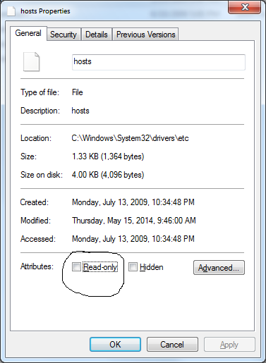
- The ‘Security’ tab specifically has your Windows account as able to modify the file
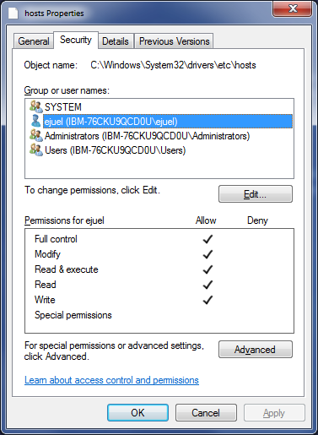

- You are listed as an Owner by clicking the ‘Advanced’ button and then choosing the ‘Ownership’ tab
